# Master Thesis – Research plan

Fears of a Utility Death Spiral: An Agent-based modelling case study of Zurich comparing individual PV adoption with community PV adoption considering policy, electricity tariff structures and PV adoption business models – and consequent policy recommendations

Student: Prakhar Mehta, MEST ([pmehta@student.ethz.ch](mailto:pmehta@student.ethz.ch))

Supervisors: Danielle Griego, PhD Candidate (+41 44 633 72 14, [griego@arch.ethz.ch](mailto:griego@arch.ethz.ch))]

Prof. Dr. Arno Schlueter (+41 (0)44 633 93 91, [schlueter@arch.ethz.ch](mailto:schlueter@arch.ethz.ch))

Starting date: 17.12.2018

End date: 10.06.2019

Work load: [1 ECTS = 25-30h, e.g. 30 ECTS = 750-900 h]

# A Introduction

Since the events of Fukushima in 2011, Switzerland has voted to stop using nuclear power and switch to renewable energy instead, with the focus being on solar PV for the urban environment. As part of the Energy Strategy 2050, the new ‘Energy Act 730.0 (EnG)’ aims to reach to 11400 GWh of renewable energy production by the year 2035 [1]. Also, the old KEV feed-in tariff scheme has been discontinued and replaced with a one-time remuneration of up to 30% of the capital costs compared to a reference case installation for PV projects less than 30 kW after 2012 [1]. There is a need to model PV adoption rates in these new market and policy conditions. Furthermore, there is a growing discussion in both industry and academia about threats of a utility death spiral due to increasing distributed energy resource (DER) adoption (particularly solar PV) which leads to higher electricity bills as the utilities increase tariffs to compensate for the grid expenses from a lesser number of customers, which leads to more customers to adopt DERs and hence a vicious cycle begins. This cycle, if unchecked, can lead to the demise of the utility. There have been conflicting academic studies ([2], [3]) about the level of threat, but a general agreement is that the demise of a utility is unlikely, given the gradual adoption of PV and regulatory aspects ([2], [4]). There have also been studies on PV adoption in Switzerland ([5], [6]), but none focus on the impact on utilities and the possibility of a death spiral and none talk about PV adoption on a community level.

There is a growing interest in Community Solar as the costs of the system can be shared among those involved and there is a greater self-consumption rate if complementary loads are connected in the system. However, collective decision making to adopt PV in the first place is more difficult. This is because many entities are involved, and each has their own interests, restrictions and economic considerations/outlook.

A paper by Muaafa et. Al [2] used Agent-based modelling (ABM) to study whether the adoption of PV (only individually, not collectively) in the US cities of Cambridge and Lancaster triggers a utility death spiral, including peer/neighbour effects. ABM represents the interaction of individuals (or, autonomous decision-making entities, called agents) with each other and the environment based on sets of rules. These rules can also be framed to simulate collective behaviour, which can be used to model how communities will decide and adopt PV. ABM is often used to model the diffusion of new technologies and is a great tool to use to model a heterogenous population mix and their decision making. [7]

In Switzerland, the energy policy [1] is such that smaller PV systems (<30 kW) get a one-time remuneration but PV systems larger than 30 kW can only accept Feed-in Tariffs. Considering that the Feed-in Tariffs are subject to change over the course of 20 years (and people cannot estimate them well enough) and the ‘Time value of Money’ [8], it will make people more likely to go for a PV system lesser than 30 kW in size (both individually or collectively as a community). Hence, my hypothesis is:

*Under current policy conditions in Zurich, PV system sizes of less than 30 kW will be preferred (hence more individual PV systems) – and it is expected that even if communities are formed for shared community PV, a majority of their system sizes will be less than 30kW.*

To test this hypothesis, this thesis aims to combine the open-source Python based ABM developed by Muaafa et. Al [2] with work done by master student Sabine Python at the Chair of iA (energy models of Zurich Wiedikon using the CEA tool). Running the model over a period of 20 years under a variety of scenarios (different utility electricity pricing schemes, government policies, mix of different building types and PV ownership options) will show us differences in PV adoption (based on system size, location) between individuals and communities, and electricity prices for the region of Zurich Alt-Wiedikon in the coming two decades. The results of such model runs can be used to make specific policy recommendations to encourage greater PV adoption for individuals or communities, while keeping the threat of a utility death spiral at minimum.

# B Goals

The goal of the thesis is to compare individual PV adoption with community PV adoption under different policy/price/PV system ownership scenarios and investigate the potential of a utility death spiral in Zurich; and suggest policy recommendations/adaptions for the greatest amount of PV penetration in the urban landscape of Zurich.

**C Methodology**

1. Combining data from Sabine’s Zurich Alt-Wiedikon energy models with the existing ABM model by Muaafa et. al [2]. Please refer Figure 1 for a schematic.
2. Additions to existing ABM to account for community PV adoption. This means a collective decision-making process will take place, and modelling this will need to account for deeper interactions among neighbours. However, I want to base these interactions purely from an economic perspective – a geographically feasible group of buildings will be considered as eligible to join a community solar PV system, and individual buildings will vote to join/not join this system. System size will be dynamically defined depending on how many buildings vote ‘Yes’ to form a community. Constraints on individual buildings will be payback times; other considerations will be minimum and maximum system sizes in order to form a community system. If the number of buildings to form a system is too low, then there will be no community PV.
3. Hence, there will be 2 models:
   1. Individual adoption
   2. Community adoption
4. Running the created models for various scenarios based on:
   1. Policies: FiTs vs one-time remuneration
   2. Electricity Prices: static and dynamic across model timeframe; different for PV adopters and non-adopters.
   3. PV Business Models: Ownership/Lease/Third-Party ownership.
   4. New Policy options: Quota mechanisms, etc.
5. Analysing results to find answers to questions like:
   1. Why do certain buildings/communities adopt PV and others not?
   2. Why are some early in adopting PV while others late?
   3. Which building types (residential/commercial/institutional etc.) adopt faster and which are slower?
6. Making policy recommendations based on the scenarios simulated.

Table 1 shows, in a very general sense, how scenarios will develop, and the kind of output results expected from the model.

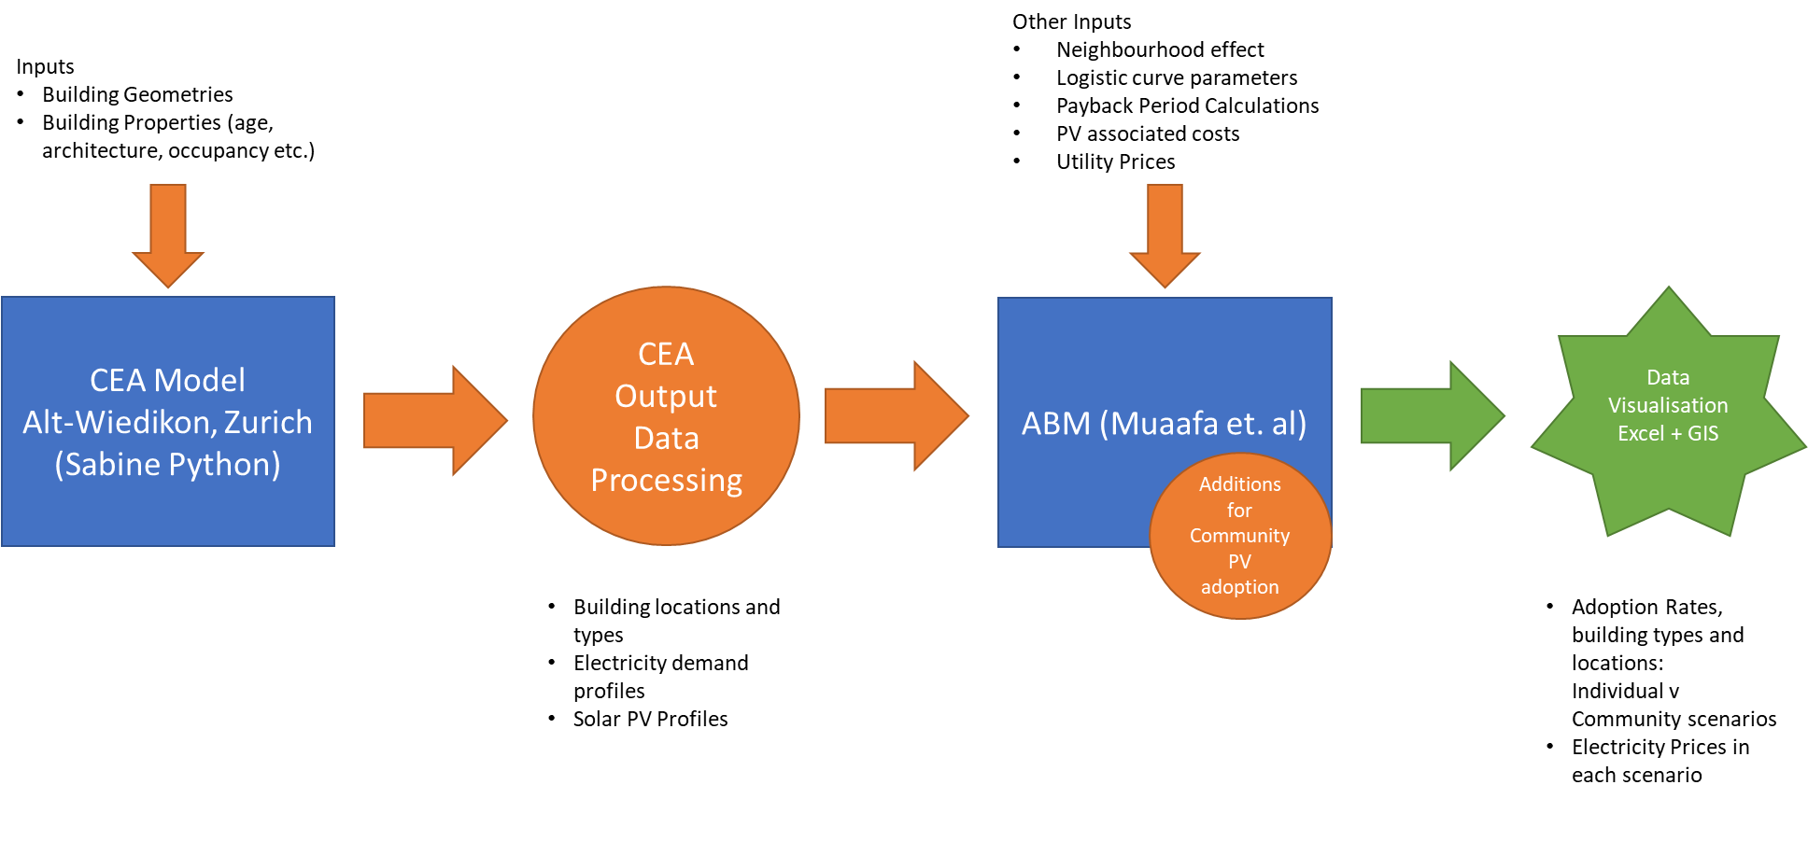

Figure 1: Schematic of Models to be used in the thesis

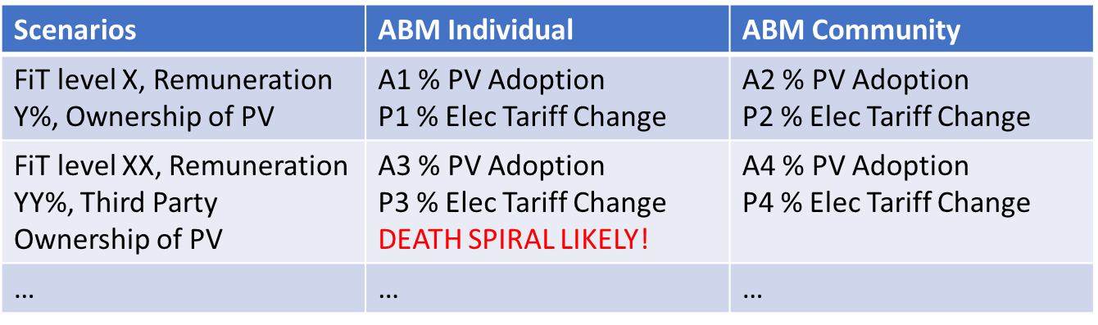

Table 1: Scenarios and Results Overview

## D Timeline

The various tasks over the course of 6 months (24 weeks) will be:

1. Literature Review:
   1. Solar PV Adoption, factors affecting PV adoption like peer effects, building types etc.
   2. Agent Based Modelling Techniques
   3. Electricity pricing strategies from local utility (EWZ in this case)
2. Data Collection:
   1. Policy projections, Electricity Prices, Utility strategies, PV prices, capacity factors etc.
   2. Input data to the ABM – includes output of the CEA like radiation and demand profiles, generated by running the CEA models.
3. Modelling: Merging Sabine’s Zurich Alt-Wiedikon energy models on the CEA tool with the existing ABM model from the paper; adding collective decision-making module to model community PV adoption
4. Analysis: Run ABMs for different scenarios as explained in C above.
5. Policy recommendations for greater solar PV adoption and minimized utility electricity price increase.
6. Report preparation and presentation.

Please refer Table 2 for the Timeline.

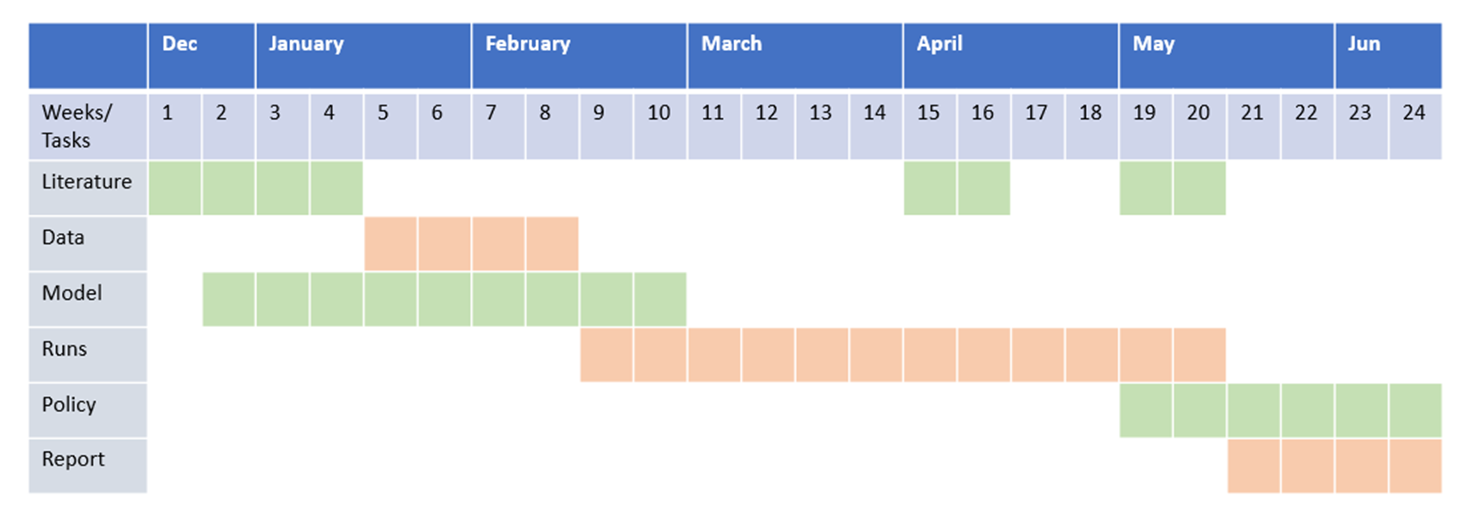

Table 2: Timeline

# E Contribution

This thesis aims to show the difference between adoption levels of individuals vs communities in Zurich. The main contribution will be the use of ABM for collective decision making for community PV adoption, and how this is dependent on a variety of factors like policy, electricity tariffs and ownership business models. Policy recommendations based on scenarios simulated, specific to community PV adoption will also be a novel contribution of this thesis.

# F References

[1] Energy Act 730.0, Swiss Federal Office of Energy (SFOE)  
<https://www.admin.ch/opc/fr/classified-compilation/20121295/index.html>

[2] Mohammed Muaafa, Iqbal Adjali, Patrick Bean, Rolando Fuentes, Steven O. Kimbrough,

Frederic H. Murphy, Can adoption of rooftop solar panels trigger a utility death spiral? A tale of two U.S. cities, Energy Research & Social Science 34 (2017) 154–162

[3] Nicholas D. Laws, Brenden P. Epps, Steven O. Peterson, Mark S. Laser, G. Kamau Wanjiru, On the utility death spiral and the impact of utility rate structures on the adoption of residential solar photovoltaics and energy storage, Applied Energy 185 (2017) 627–641

[4] Kenneth W. Costello and Ross C. Hemphill, Electric Utilities’ ‘Death Spiral’: Hyperbole or Reality? Available: <http://dx.doi.org/10.1016/j.tej.2014.09.011>

[5] Alejandro Nuñez-Jimenez, Enhancing PV systems adoption by Swiss households, a system dynamics policy analysis, Semester Project at Chair Management of Network Industries under Prof. Matthias Finger, École Polytechnique Fédérale de Lausanne. Available: <https://www.researchgate.net/publication/312219351>

[6] Stavroula Margelou, Assessment of long term solar PV diffusion in Switzerland: Agent-based diffusion model for single family houses, Master Thesis carried out at Paul Scherrer Institut (PSI) – Villigen, Switzerland under Prof. Matthias Finger (MIR)

[7] Eric Bonabeau, Agent-based modeling: Methods and techniques for simulating human systems, 7280–7287 PNAS, May 14, 2002, vol. 99, suppl. 3. Available: [www.pnas.org/cgi/doi/10.1073/pnas.082080899](http://www.pnas.org/cgi/doi/10.1073/pnas.082080899)

[8] Time Value of Money: <https://www.investopedia.com/terms/t/timevalueofmoney.asp>

# G Planned Deliverables

**Mid-term presentation:** March Week 2/3. At the middle of the project, the work will be presented to the supervisors and interested persons for feedback.

**Draft report:** June Week 1. 1 week prior to the final presentation a pdf of the draft report will be sent to the supervisors.

**Final presentation:** June Week 2/3. At the end of the project, the work will be presented to the chair during a group meeting or equivalent.

**Final report:** June Week 2/3. Final report (PDF, hard copy, simulation files, …) is due on/before the end date.